It is OK to ask for Help!

Did you know that many people think it is a weakness to ask for help?
Even though this is the message some of us grew up with, we are here to tell you that asking for help is not a sign of weakness but a sign of courage.
When to ask for help?
Try not to wait until everything gets out of control. Getting the help, you need can prevent that from happening. If you are concerned about how you are feeling, what you are doing and what you are thinking asking for help shows you are choosing to make positive changes you can’t do on your own.
Why ask for help?
Sometimes, we know what the problem is, but we do not know how to fix it. We do not have to do everything by ourselves. Getting help from a family member, a friend or a therapist can alleviate a lot of the pressure we have.
Remember that when you are emotionally well, you can take better care of your family.

For more information go to www.selfhelpcpc.org
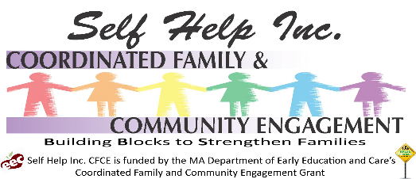
Look for speaking from the heart.

